Task_1
Data Cleaning Explanation

Data Cleaning Process

1. Creating a Cleaned Dataset
A new sheet named “Cleaned_Data” was created, and all data cleaning operations were performed in this sheet while keeping the original dataset unchanged to maintain data integrity.

2. Handling Missing Values and Standardization

Order_ID Column:
The Order_ID column did not contain any missing or duplicate values. Therefore, it was directly copied to the cleaned dataset without any modifications, ensuring that each record remains uniquely identifiable.
- Product Column:
The Product column was cleaned using the formula:
=IF(TRIM(Raw_Data!B2)="","Unknown",PROPER(TRIM(Raw_Data!B2)))
This was done to remove extra spaces and convert product names into a consistent format. Missing values were replaced with "Unknown" to avoid loss of data and maintain completeness.
- Region Column:
The Region column was cleaned using the formula:
=IF(TRIM(Raw_Data!C2)="","South",TRIM(Raw_Data!C2))
Missing values were replaced with "South", which was identified as the mode (most frequent value) using a Pivot Table. This ensures consistency and prevents unnecessary data loss.
- Revenue Column:
The Revenue column was cleaned using the formula:
=IF(TRIM(Raw_Data!D2)="",30435.80739,Raw_Data!D2)
Missing values were replaced with the average revenue (30435.80739). This approach helps maintain the dataset size and avoids distortion in total revenue calculations.
- Date Column:
The Date column was standardized using the formula:
=TEXT(Raw_Data!E2,"DD-MM-YYYY")
This ensures all date values follow a consistent format, which is important for time-based analysis.

3. Duplicate Handling
Duplicate records were checked and removed to ensure that each transaction is unique and to prevent inaccuracies in analysis.

4. Data Consistency and Validation
After cleaning, the dataset was verified to ensure:
- No missing values in critical columns
- Consistent formatting across all fields
- No duplicate records

5. Justification Summary
- Missing categorical values (Product, Region) were handled using replacement methods to retain maximum data.
- Missing numerical values (Revenue) were filled using the average to avoid skewing results.
- Text fields were standardized to ensure accurate grouping and analysis.
- Original data was preserved to maintain transparency and reproducibility.

Conclusion
The dataset was successfully cleaned and prepared for analysis by handling missing values, removing duplicates, and standardizing formats, ensuring reliable and accurate results in further stages.

Task_2
Data_Analysis_Explanation
- Total sales-36522968.87
- Region-Wise Sales-
Region | Count of Region
East | 275
North | 292
South | 344
West | 289
Grand Total | 1200

- Top products-
Products | Sum of Revenue
Keyboard | 6509041.121
Laptop | 6579854.814
Monitor | 6531293.314
Mouse | 7333008.519
Tablet | 7450700.569
Unknown | 2119070.53
Grand Total | 36522968.87

Insights
- The South region generates the highest revenue.
- Product Tablet is the top-performing product.
- Some regions contribute very low sales, indicating growth opportunities.

TASK_3
SQL QUERIES
SQL queries were performed using MySQL Workbench to analyze the cleaned sales dataset. The objective was to extract meaningful insights such as total revenue, region-wise performance, and top-performing products.

1. Total Revenue
Query:
SELECT SUM(Revenue) AS total_revenue FROM sales_data;
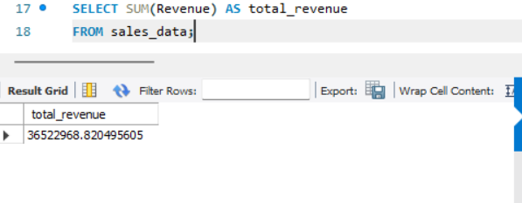
This query calculates the total revenue generated from all sales records in the dataset.

2. Revenue by Region
Query:
SELECT Region, SUM(Revenue) AS revenue FROM sales_data GROUP BY Region;
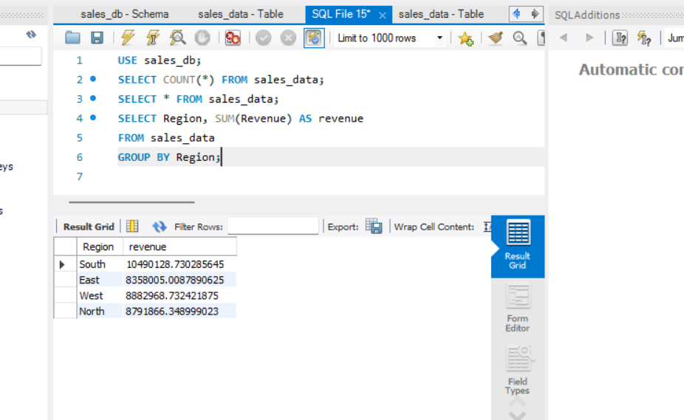
This query groups the data by region and calculates total revenue for each region, helping identify the best-performing regions.

3. Top Products
Query:
SELECT Product, SUM(Revenue) AS total FROM sales_data GROUP BY Product ORDER BY total DESC LIMIT 5;
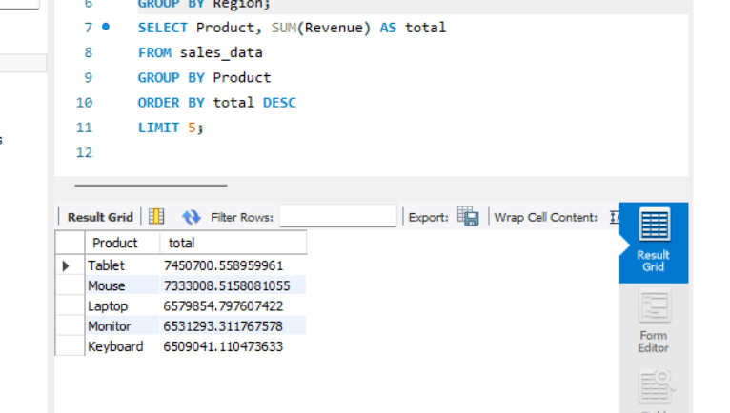
This query identifies the top 5 products based on total revenue, showing which products contribute most to overall sales.
- Average Revenue
Query:
SELECT AVG(Revenue) AS avg_revenue FROM sales_data;
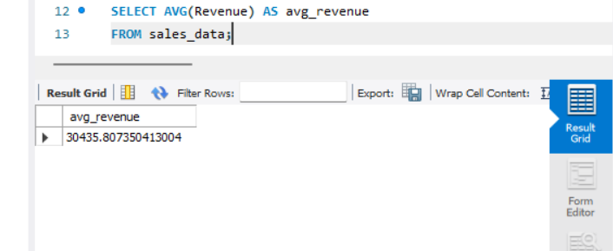
This query calculates the average revenue across all transactions, providing an overall performance metric.

5. Filtered Results
Query:
SELECT * FROM sales_data WHERE Revenue > 59500;
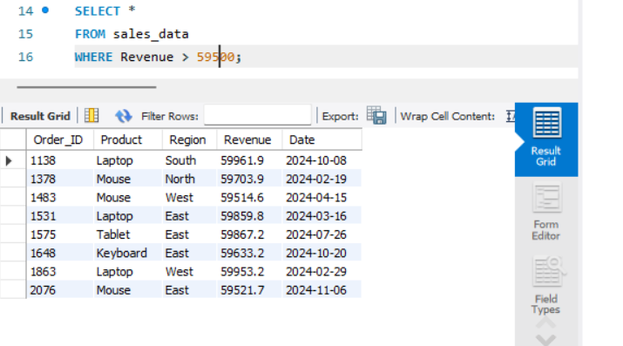
This query filters and displays records where revenue is greater than 30000, helping identify high-value transactions

Conclusion
The SQL queries successfully extracted key insights from the dataset, enabling better understanding of sales performance across regions and products.

TASK_4
DASHBOARD CREATION

Introduction
A Power BI dashboard was created to visualize the sales data effectively. The dashboard provides insights into total revenue, regional performance, product performance, and sales trends.
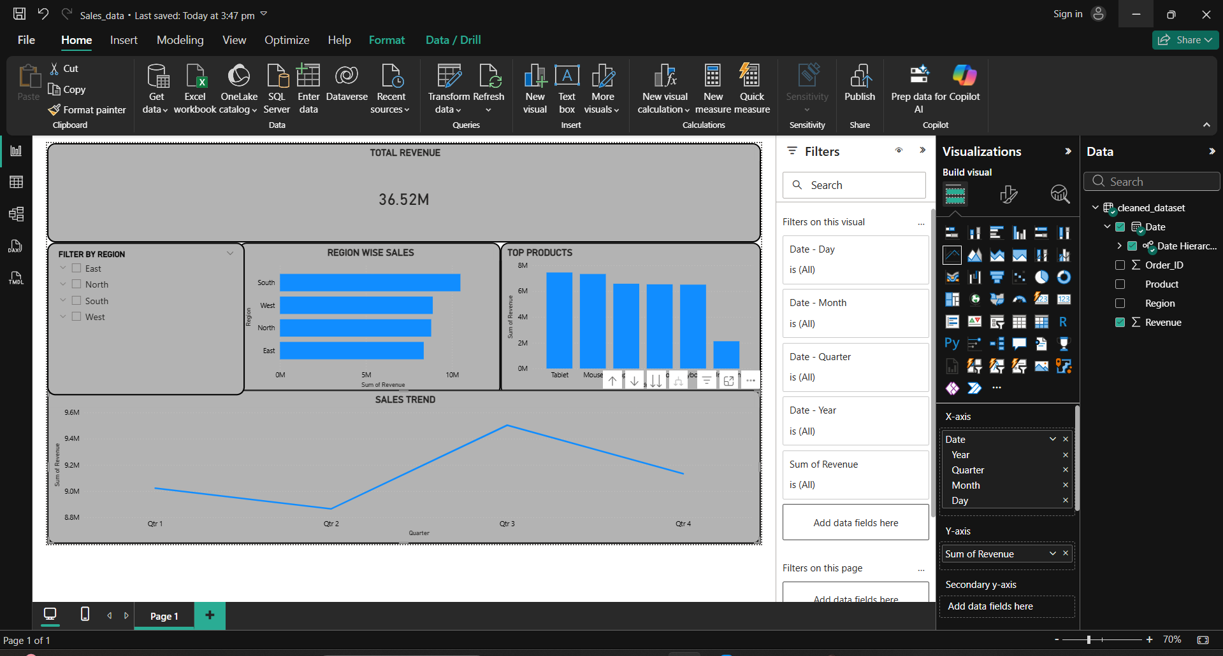

Description of Dashboard
The dashboard consists of the following components:
- Total Revenue (Card): Displays the overall revenue generated from all sales transactions.
- Revenue by Region (Bar Chart): Shows the comparison of sales across different regions.
- Top Products (Column Chart): Highlights the top-performing products based on revenue.
- Sales Trend (Line Chart): Illustrates how revenue changes over time.
- Filters (Slicers): Allows users to filter the data based on region and product for better analysis.

Conclusion
The dashboard helps in understanding key sales patterns and supports better decision-making through interactive visualizations.

Insights and Recommendations

Introduction
The sales dataset was analyzed using Excel, SQL, and Power BI to identify patterns, trends, and performance indicators. The objective of this analysis is to derive meaningful business insights and provide actionable recommendations to improve sales performance.

Key Insights
- Revenue Distribution Across Regions
The analysis shows that certain regions contribute significantly more to total revenue compared to others. This indicates an uneven distribution of sales performance across regions.
- Top-Performing Products
A small group of products generates a major portion of the total revenue. These top-performing products play a crucial role in overall business success.
- Sales Trend Over Time
The sales trend analysis reveals fluctuations in revenue over different periods. There are specific time periods where sales are noticeably higher or lower.
- High-Value Transactions
Some transactions contribute significantly higher revenue compared to others. These high-value sales have a strong impact on total revenue.
- Average Revenue Insight
The average revenue provides a benchmark to evaluate individual transactions. Transactions above this value can be considered strong performers.

Business Recommendations
- Focus on High-Performing Regions
Increase investment, marketing efforts, and inventory in top-performing regions to maximize revenue generation.
- Improve Underperforming Regions
Analyze low-performing regions to identify issues such as lack of demand, poor marketing, or supply chain problems, and take corrective actions.
- Promote Top Products
Boost sales by promoting high-performing products through discounts, advertisements, and bundling strategies.
- Optimize Low-Performing Products
Review products with low sales and consider improving their quality, pricing strategy, or discontinuing them if necessary.
- Leverage Sales Trends
Identify peak sales periods and plan marketing campaigns, stock management, and offers during those times to maximize profit.
- Target High-Value Customers
Focus on customers or segments that generate high-value transactions and create strategies to retain them.

Conclusion
The analysis highlights key factors influencing sales performance, including regional differences, product performance, and time-based trends. By implementing the above recommendations, the business can improve revenue, optimize operations, and achieve better overall performance.

